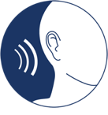 | CLB 1-4 LISTENING SKILL USING:  Choose clothes/activities for the weather

Possible Skill-Building Activities:

- Weather: https://monicazesl.com/basics1/weather/
- Weather: https://www.learningchocolate.com/content/weather-10
- How’s the weather?: https://www.youtube.com/watch?v=rD6FRDd9Hew&feature=emb_logo
- More weather: https://www.learningchocolate.com/content/weather
- CLB 1 What is the weather like?: https://tutela.ca/Resource_18057
- CLB 1 The weather forecast: https://tutela.ca/Resource_18053
- Greeting neighbours on a sunny day: http://englishinvancouver.blogspot.com/search/label/Lesson%2001%3A%20Greetings%20-%20Sunny%20Day
- Greeting neighbours on a rainy day: http://englishinvancouver.blogspot.com/search/label/Lesson%2002%3A%20Greetings%20-%20Rainy%20Day
- Train station greetings – weather: http://englishinvancouver.blogspot.com/search/label/Lesson%2004%3A%20Train%20Station%20-%20Greetings%20-%20Weather
- Outdoor temperature: https://www.learningchocolate.com/content/outdoor-temperature
- Weather matching game: https://www.esolcourses.com/uk-english/beginners-course/unit-4/weather-months-seasons/weather-picture-quiz.html
- Weather: https://www.allthingstopics.com/weather.html
- Mo stays warm: https://globalaccess.bowvalleycollege.ca/esl-readers/mo-stays-warm/
- A cold winter day: https://globalaccess.bowvalleycollege.ca/esl-readers/a-cold-winter-day/
- Mursal’s trip to school: https://globalaccess.bowvalleycollege.ca/esl-readers/mursal%27s-trip-to-school/
- Prepared for winter: https://globalaccess.bowvalleycollege.ca/esl-readers/prepared-for-winter/
- Fun on the weekend: https://globalaccess.bowvalleycollege.ca/esl-readers/fun-on-the-weekend/
- CLB 3 Interpreting Canadian weather tables: https://tutela.ca/Resource_1462
- CLB 3 Weather forecasts: https://tutela.ca/Resource_1536
- Listening to an English forecast: https://www.youtube.com/watch?v=ABVG_9Yg4q8&list=PL5bLw9Uguvv3Mjnzd0YGmu-lGRWRWv-cU&index=4&t=3s
- Listening to an English weather forecast: https://www.youtube.com/watch?v=nPL30d-IHoY&list=PL5bLw9Uguvv1VRVl3gHBt-FcM__k3UY9L&index=19&t=1s
- Spring weather report: http://englishinvancouver.blogspot.com/search/label/Lesson%2052%3A%20Spring%20Weather%20Report
- Winter weather report: http://englishinvancouver.blogspot.com/search/label/L3%20-%20Lesson%2019%3A%20Winter%20Weather%20Report
- Listening practice – weather: https://www.youtube.com/watch?v=J4Sqf0F7dec

**Note: See the following pages for skill-using tools.**
Name: _______________________________ Date: _____________
CLB 1 LISTENING SKILL USING:
Choose clothes for the weather
1.3 Getting things done • I can understand very simple warnings in everyday situations.
1.4 Comprehending Information • I can understand very simple information about very familiar, clear topics.
INSTRUCTIONS: Read the questions. Circle your answers.
1. This listening was…
 | easy | so-so | hard
2. I listened…
1 | 2 | 3 | 4+
time | times | times | times
3. My answers were… |  | Correct | Incorrect
(1) What is the weather? (1.4)
(2) What do you need? (1.3)

4. I will practise listening by…
doing my homework | studying my  class notes |  | talking to  my classmates | listening to weather words | watching English videos online
My teacher says:

Name: _______________________________ Date: _____________
CLB 2 LISTENING SKILL USING:
Choose clothes for the weather
2.3 Getting things done • I can understand and respond to warnings in everyday situations.
2.4 Comprehending Information • I can understand simple information about familiar, clear topics.

INSTRUCTIONS: Read the questions. Circle your answers.
1. This listening was…
 | easy | so-so | hard
2. I listened…
1 | 2 | 3 | 4+
time | times | times | times
3. My answers were… |  |  | Correct | Incorrect
(1) What is the weather? (2.4)
(2) Click the BEST clothes for Natalie. (2.3)

4. I will practise listening by…
doing my homework | studying my  class notes |  | talking to  my classmates | listening to weather words | watching English videos online
My teacher says:

Name: _______________________________ Date: _____________
CLB 3 LISTENING SKILL USING:
Choose activities for the weather
3.3 Getting things done • I can understand and respond to common warnings.
3.4 Comprehending Information • I can understand short descriptions about familiar, clear topics.
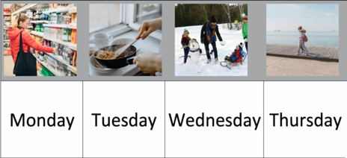

INSTRUCTIONS: Read the questions. Circle your answers.
1. (a) This listening was…
 | easy |  | so-so |  | Hard
(b) Challenges:
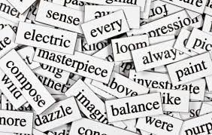
vocabulary  (I didn’t know all the words.) | speed  (It was fast.) | length  (It was long.) |  | sound/volume  (It was hard to hear.)
 |  |  |  | other:
instructions  (I didn’t understand the instructions.) | technology  (I had problems with my device/internet.) | pictures/words  (The pictures and/or words were hard to see.)
2. I listened…
1 | 2 | 3 | 4+
time | times | times | times
3. My score was… |  | __ / 8
4. I tried this activity…
1 | 2 |  | 3 4+
time | times |  | times times
5. My answers were… |  |  |  | Correct | Incorrect
(1) What is the weather? (3.4)
(2) Click the best activity for the day. (3.3)

6. I will practise listening by…
 |  |  |  |  |  | 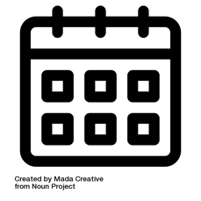 | 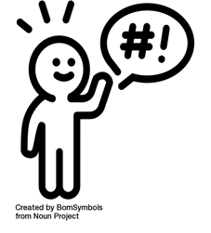
doing my homework | studying my  class notes |  | talking to  my classmates | listening to weather words | watching English videos online | listening to time words | listening to warnings and suggestions
My teacher says:

Name: _______________________________ Date: _____________
CLB 4 LISTENING SKILL USING:
Choose activities for the weather
4.3 Getting things done • I can understand and respond to common warnings.
4.4 Comprehending Information • I can understand short descriptions about familiar, clear topics.
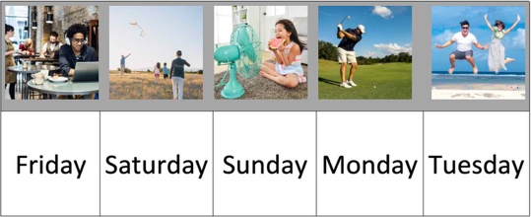

INSTRUCTIONS: Read the questions. Circle your answers.
1. (a) This listening was…
 | easy |  | so-so |  | Hard
(b) Challenges:
vocabulary  (I didn’t know all the words.) | speed  (It was fast.) | length  (It was long.) |  | sound/volume  (It was hard to hear.)
 |  |  |  | other:
instructions  (I didn’t understand the instructions.) | technology  (I had problems with my device/internet.) | pictures/words  (The pictures and/or words were hard to see.)
2. I listened…
1 | 2 | 3 | 4+
time | times | times | times
3. My score was… |  | __ / 10
4. I tried this activity…
1 | 2 |  | 3 4+
time | times |  | times times
5. My answers were… |  |  |  | Correct | Incorrect
(1) What is the weather? (4.4)
(2) Click the best activity for the day. (4.3)

6. I will practise listening by…
 |  |  |  |  |  |  | 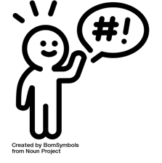
doing my homework | studying my  class notes |  | talking to  my classmates | listening to weather words | watching English videos online | listening to time words | listening to warnings and suggestions
My teacher says:

